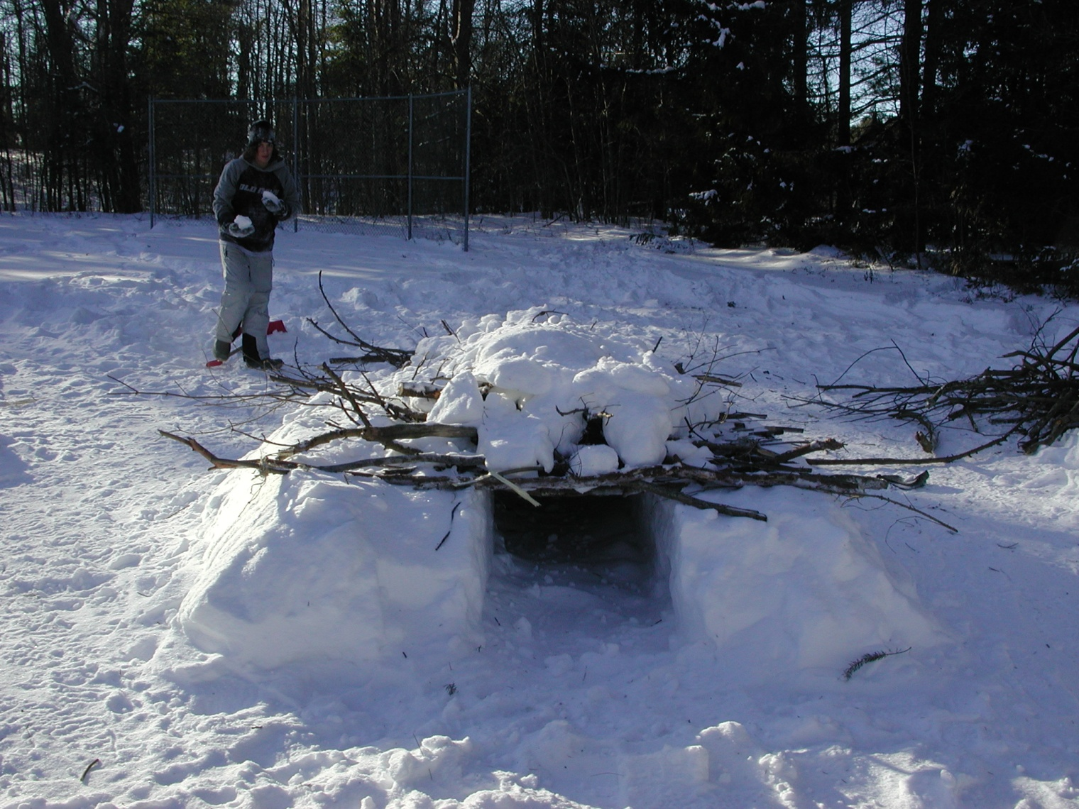
Snow Shelter
JANUARY | S | M | T | W | T | F | S
JANUARY |  |  | 1 | 2 | 3 | 4 | 5
JANUARY | 6 | 7 | 8 | 9 | 10 | 11 | 12
2013 | 13 | 14 | 15 | 16 | 17 | 18 | 19
2013 | 20 | 21 | 22 | 23 | 24 | 25 | 26
2013 | 27 | 28 | 29 | 30 | 31

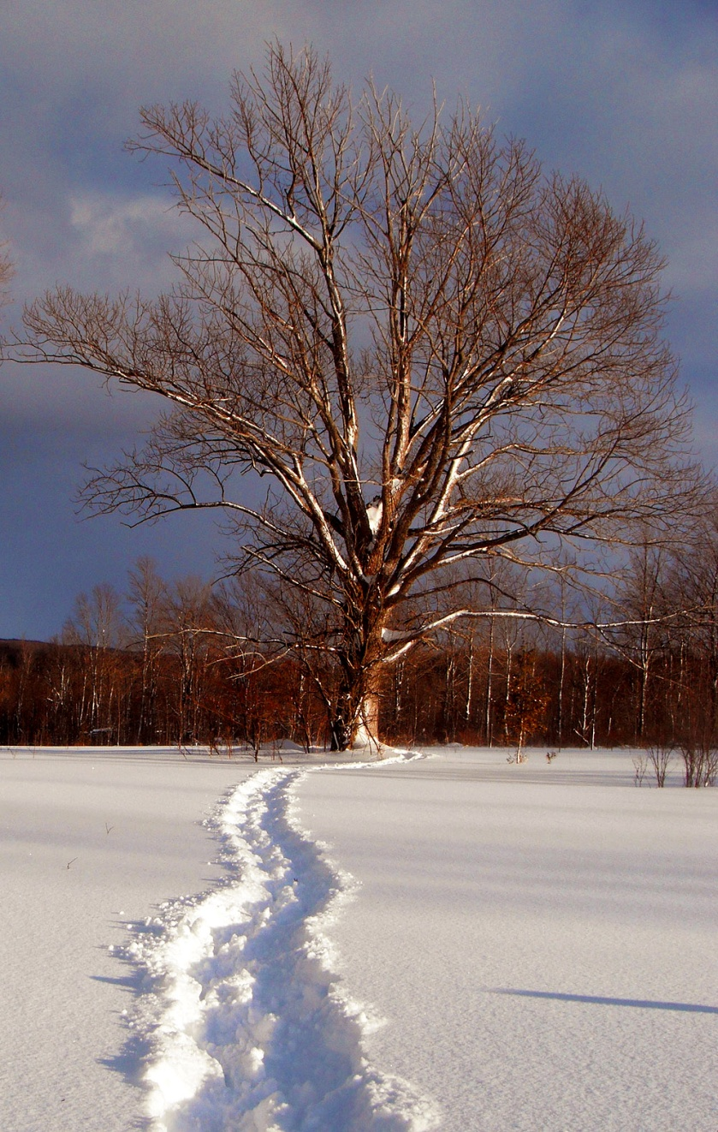
Winter Camp
FEBRUARY | S | M | T | W | T | F | S
FEBRUARY |  |  |  |  |  | 1 | 2
FEBRUARY | 3 | 4 | 5 | 6 | 7 | 8 | 9
2013 | 10 | 11 | 12 | 13 | 14 | 15 | 16
2013 | 17 | 18 | 19 | 20 | 21 | 22 | 23
2013 | 24 | 25 | 26 | 27 | 28

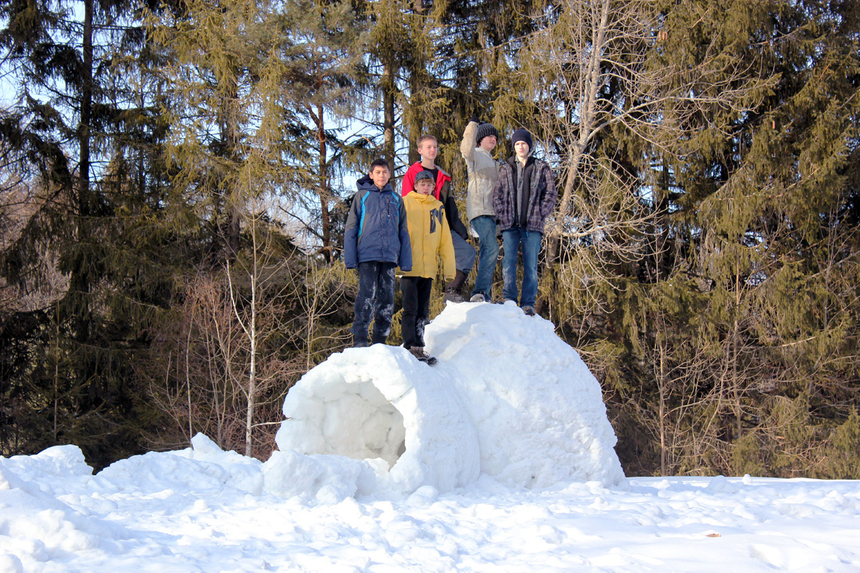
Igloo Making
MARCH | S | M | T | W | T | F | S
MARCH |  |  |  |  |  | 1 | 2
MARCH | 3 | 4 | 5 | 6 | 7 | 8 | 9
2013 | 10 | 11 | 12 | 13 | 14 | 15 | 16
2013 | 17 | 18 | 19 | 20 | 21 | 22 | 23
2013 | 24 | 25 | 26 | 27 | 28 | 29 | 30
2013 | 31

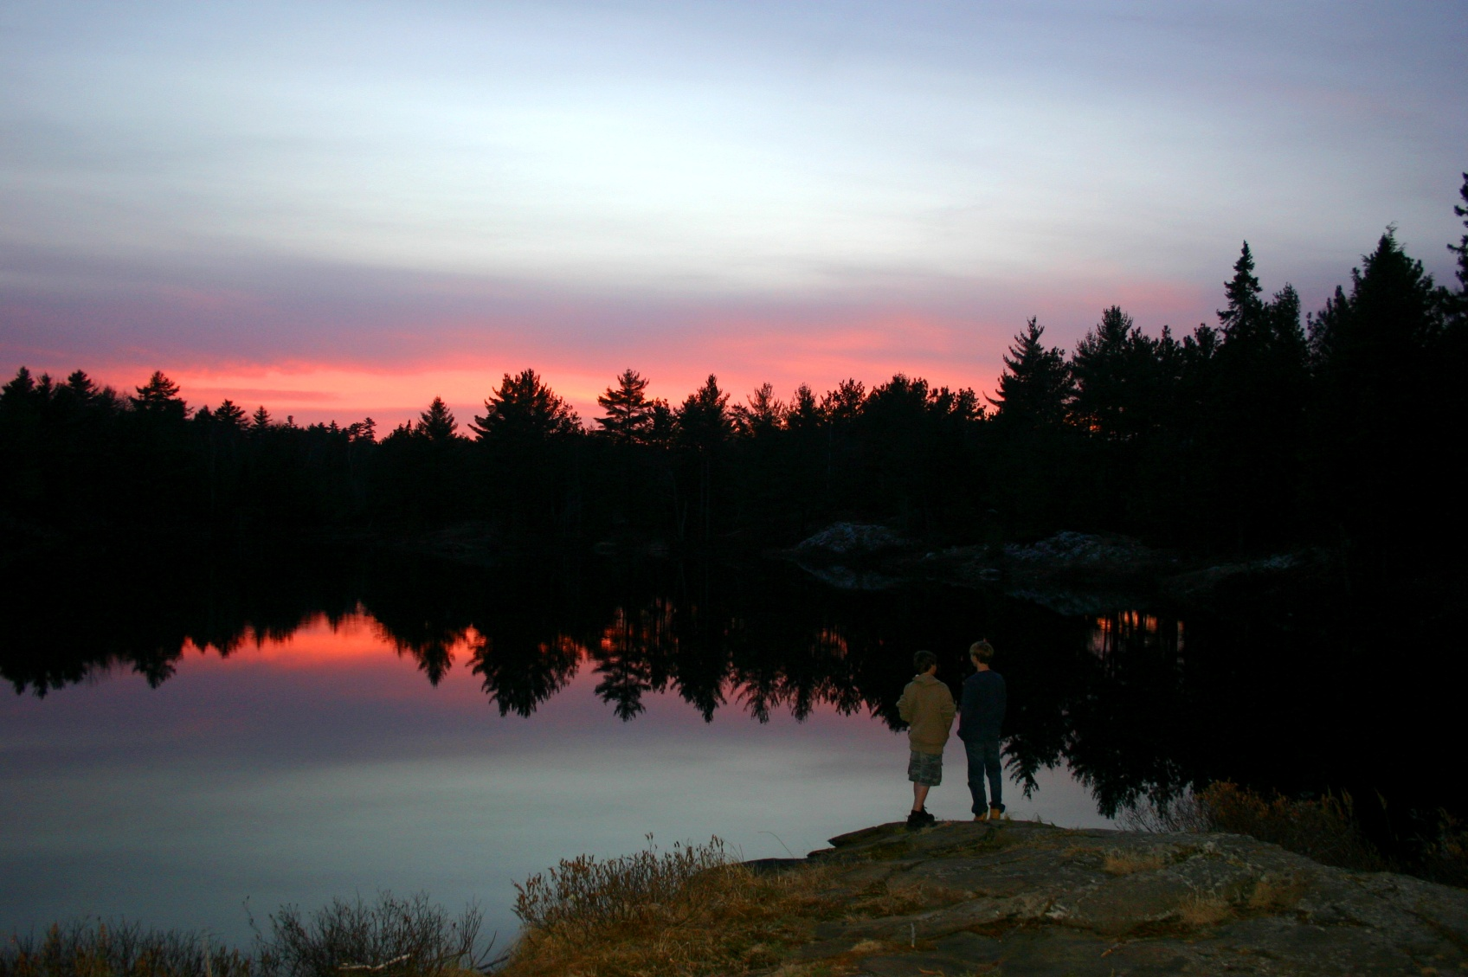
Killarney Sunset
APRIL | S | M | T | W | T | F | S
APRIL |  | 1 | 2 | 3 | 4 | 5 | 6
APRIL | 7 | 8 | 9 | 10 | 11 | 12 | 13
2013 | 14 | 15 | 16 | 17 | 18 | 19 | 20
2013 | 21 | 22 | 23 | 24 | 25 | 26 | 27
2013 | 28 | 29 | 30

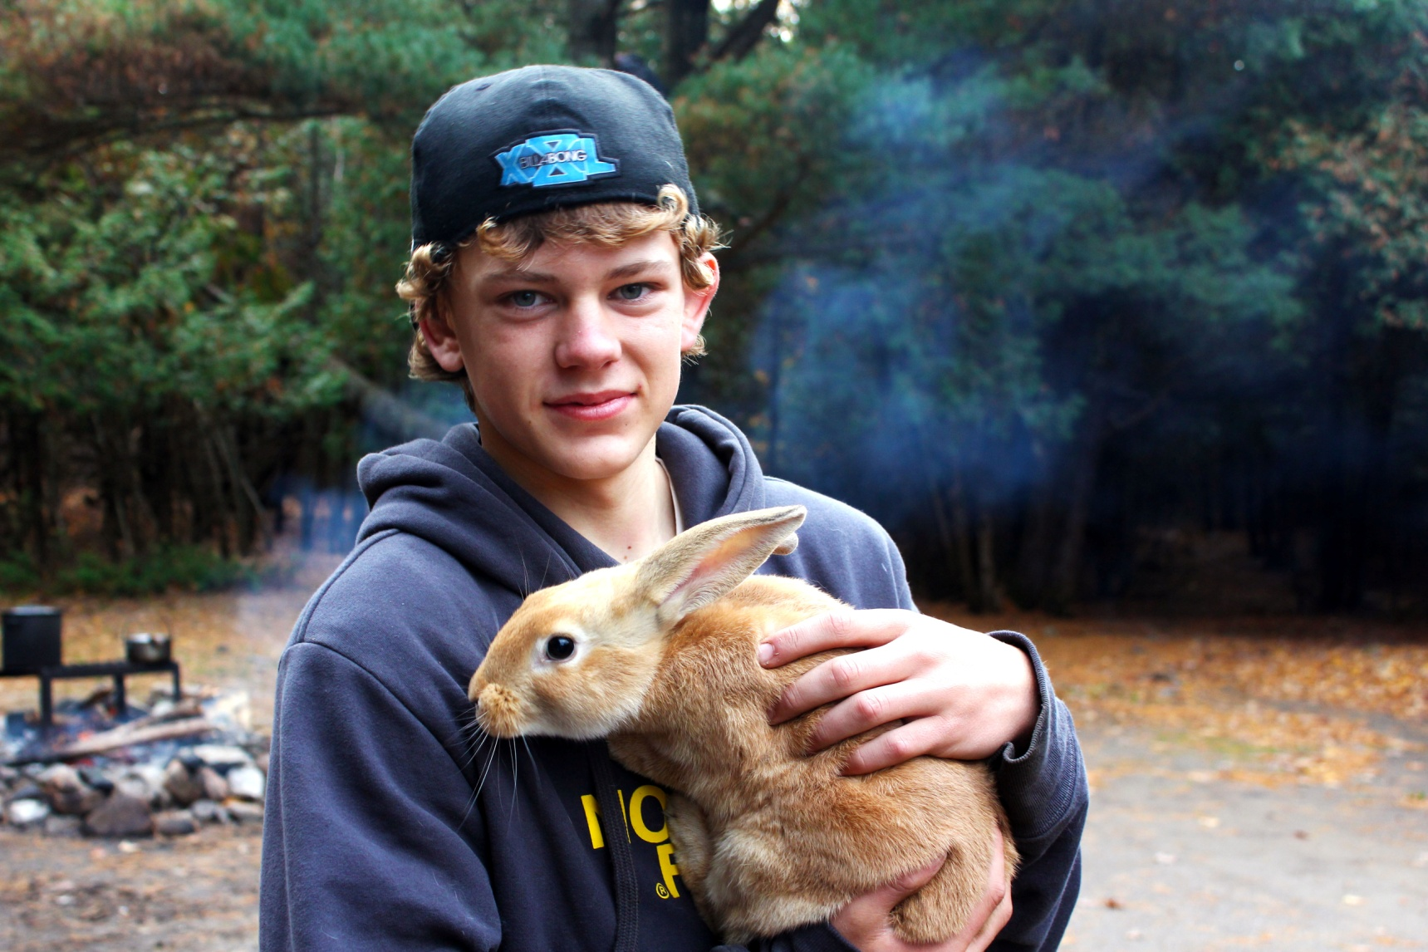
Rabbit Stew
MAY | S | M | T | W | T | F | S
MAY |  |  |  | 1 | 2 | 3 | 4
MAY | 5 | 6 | 7 | 8 | 9 | 10 | 11
2013 | 12 | 13 | 14 | 15 | 16 | 17 | 18
2013 | 19 | 20 | 21 | 22 | 23 | 24 | 25
2013 | 26 | 27 | 28 | 29 | 30 | 31

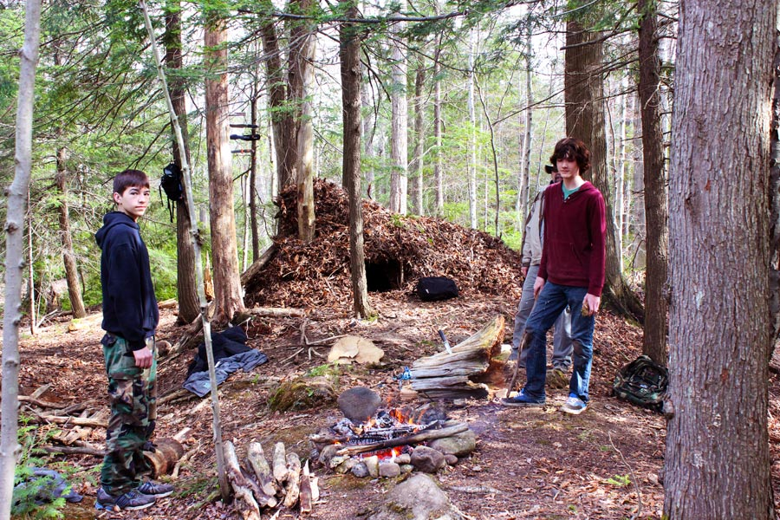
Survival Campsite
JUNE | S | M | T | W | T | F | S
JUNE |  |  |  |  |  |  | 1
JUNE | 2 | 3 | 4 | 5 | 6 | 7 | 8
2013 | 9 | 10 | 11 | 12 | 13 | 14 | 15
2013 | 16 | 17 | 18 | 19 | 20 | 21 | 22
2013 | 23 | 24 | 25 | 26 | 27 | 28 | 29
2013 | 30

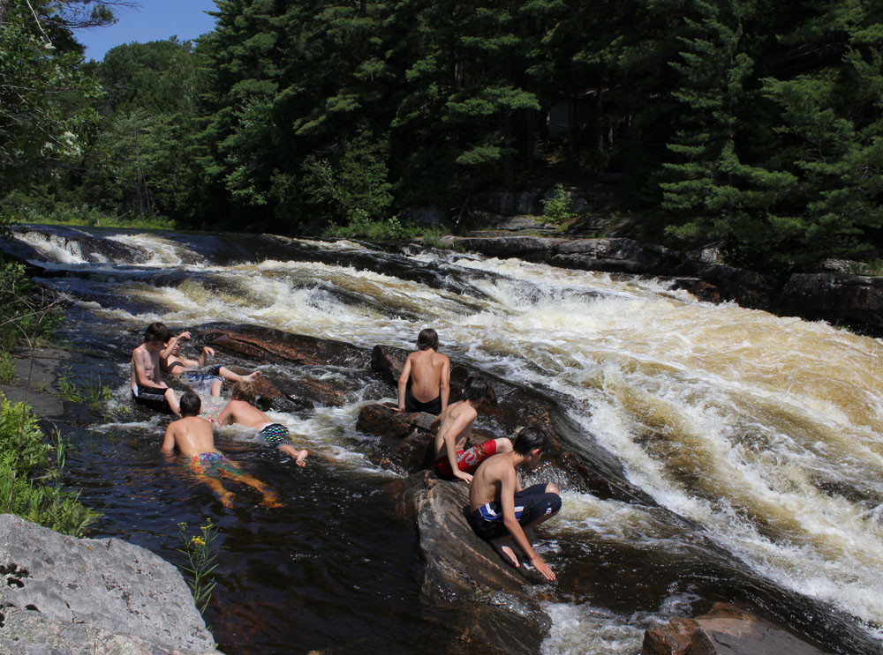
Swimming In Rapids
JULY | S | M | T | W | T | F | S
JULY |  | 1 | 2 | 3 | 4 | 5 | 6
JULY | 7 | 8 | 9 | 10 | 11 | 12 | 13
2013 | 14 | 15 | 16 | 17 | 18 | 19 | 20
2013 | 21 | 22 | 23 | 24 | 25 | 26 | 27
2013 | 28 | 29 | 30 | 31
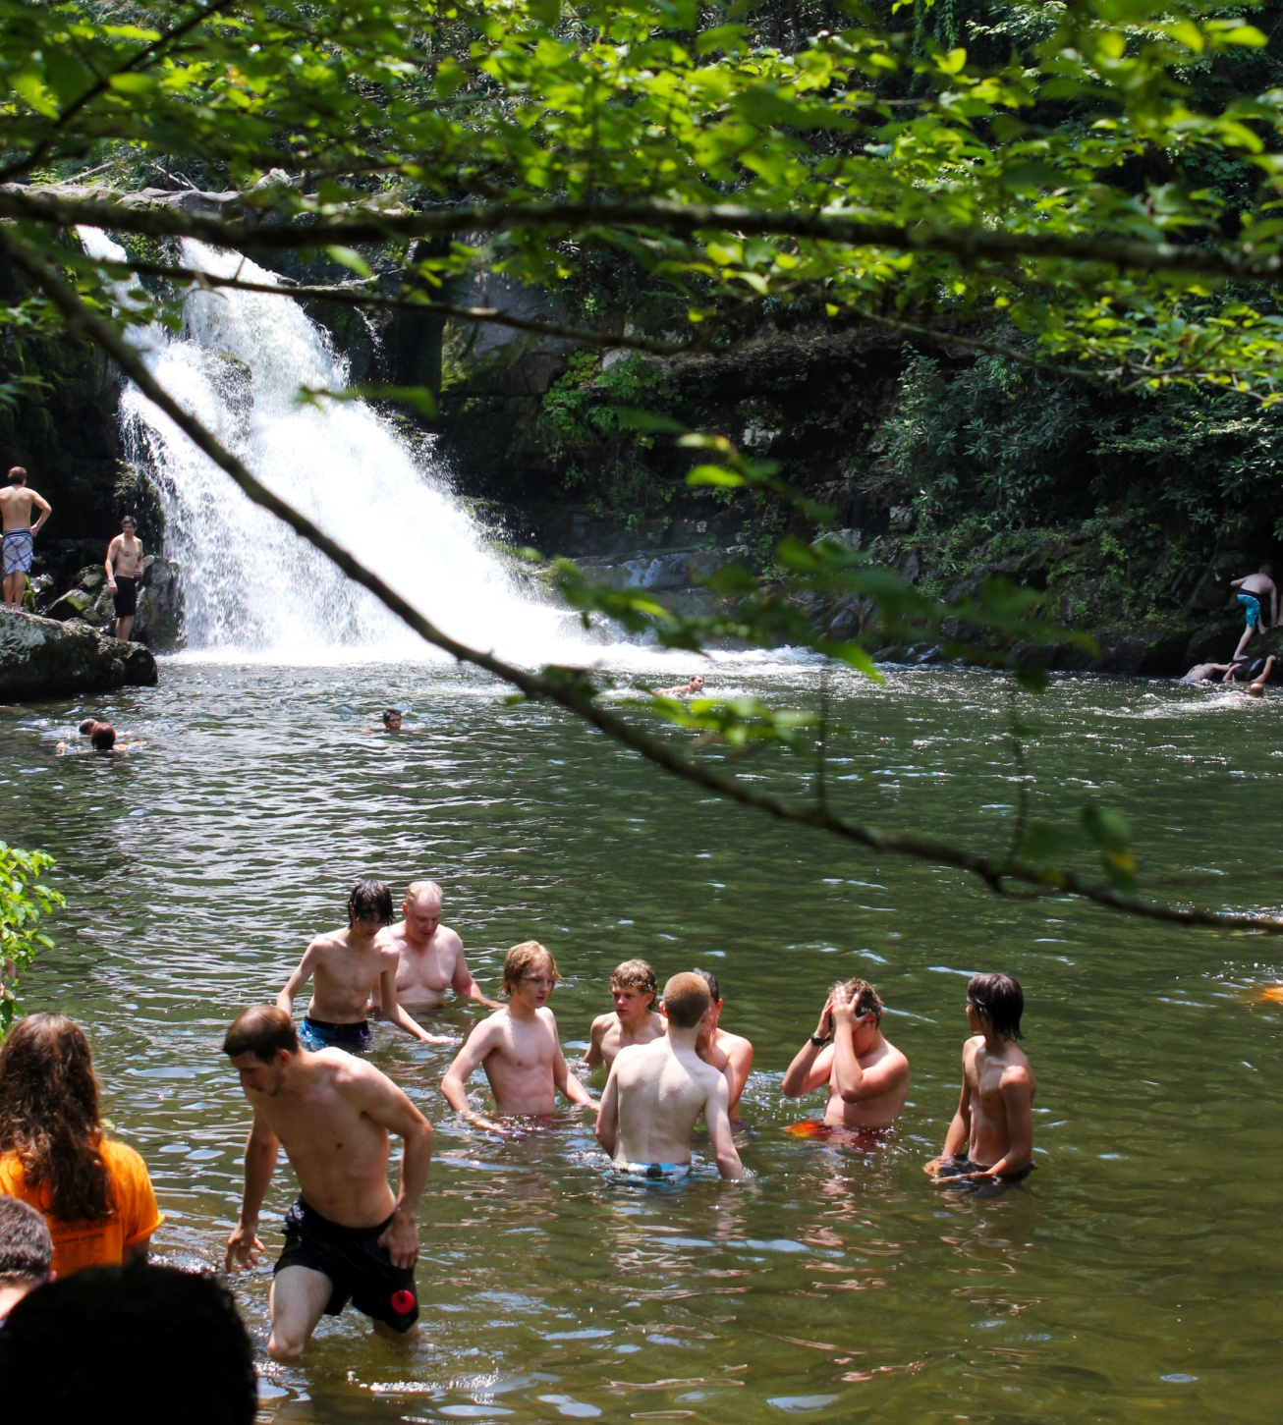
Smoky Mountain Waterfall
AUGUST | S | M | T | W | T | F | S
AUGUST |  |  |  |  | 1 | 2 | 3
AUGUST | 4 | 5 | 6 | 7 | 8 | 9 | 10
2013 | 11 | 12 | 13 | 14 | 15 | 16 | 17
2013 | 18 | 19 | 20 | 21 | 22 | 23 | 24
2013 | 25 | 26 | 27 | 28 | 29 | 30 | 31

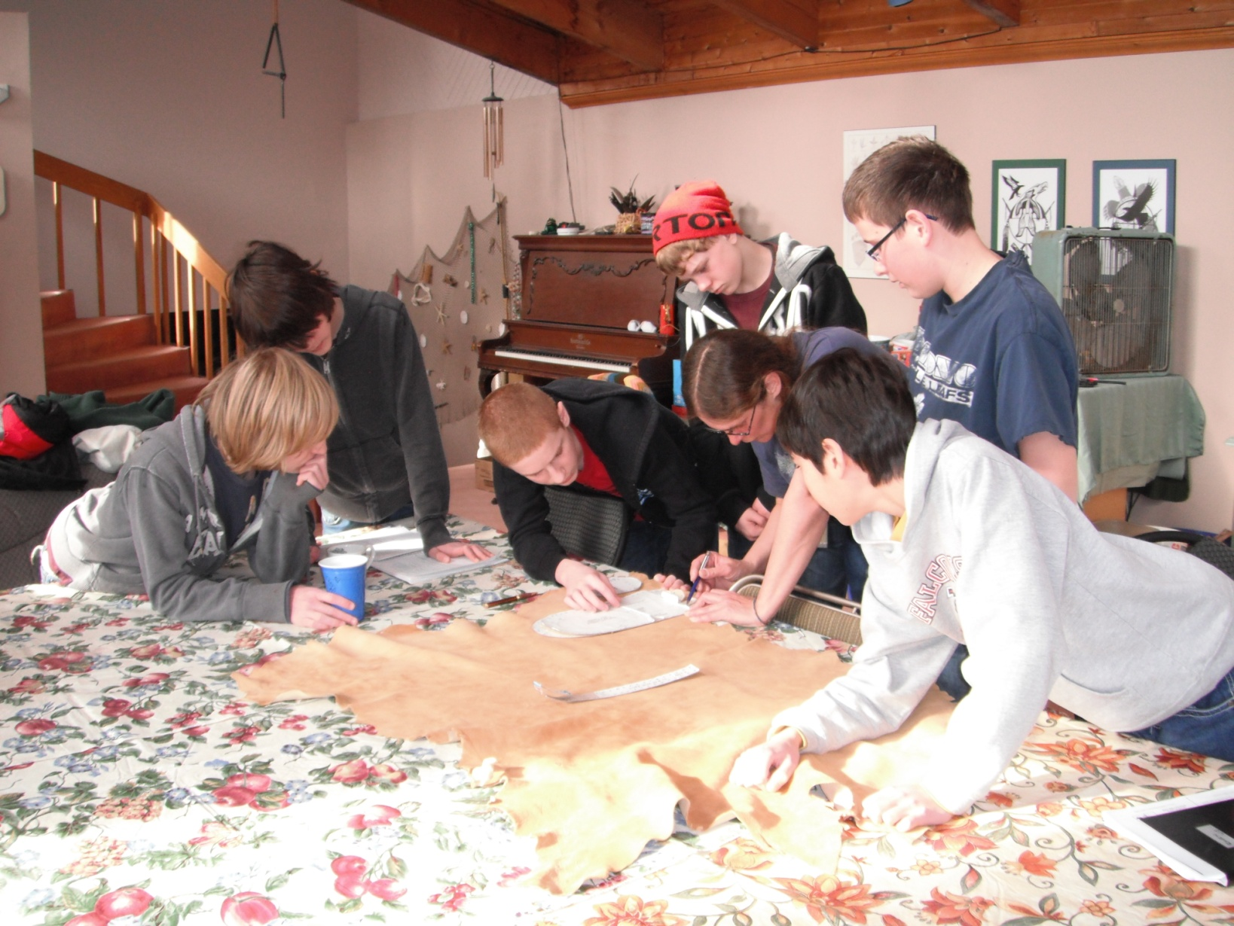
Making Moccasins
SEPTEMBER | S | M | T | W | T | F | S
SEPTEMBER | 1 | 2 | 3 | 4 | 5 | 6 | 7
SEPTEMBER | 8 | 9 | 10 | 11 | 12 | 13 | 14
2013 | 15 | 16 | 17 | 18 | 19 | 20 | 21
2013 | 22 | 23 | 24 | 25 | 26 | 27 | 28
2013 | 29 | 30

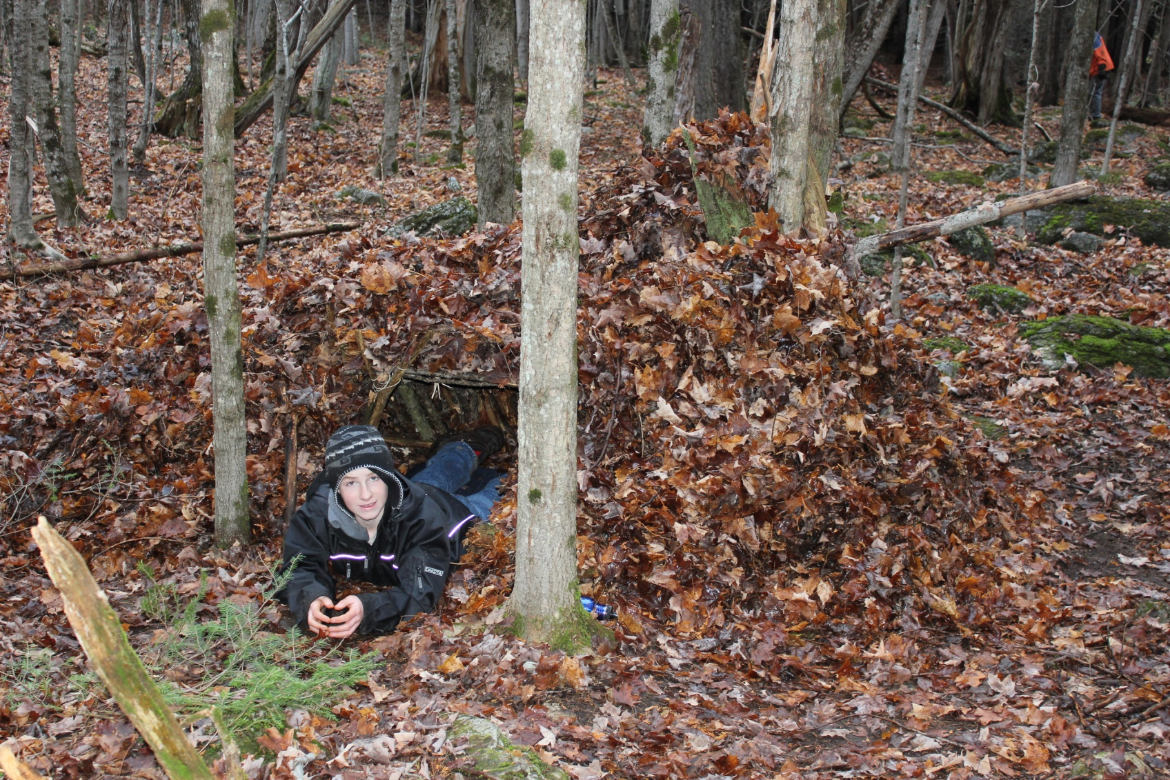
Debris Shelter
OCTOBER | S | M | T | W | T | F | S
OCTOBER |  |  | 1 | 2 | 3 | 4 | 5
OCTOBER | 6 | 7 | 8 | 9 | 10 | 11 | 12
2013 | 13 | 14 | 15 | 16 | 17 | 18 | 19
2013 | 20 | 21 | 22 | 23 | 24 | 25 | 26
2013 | 27 | 28 | 29 | 30 | 31

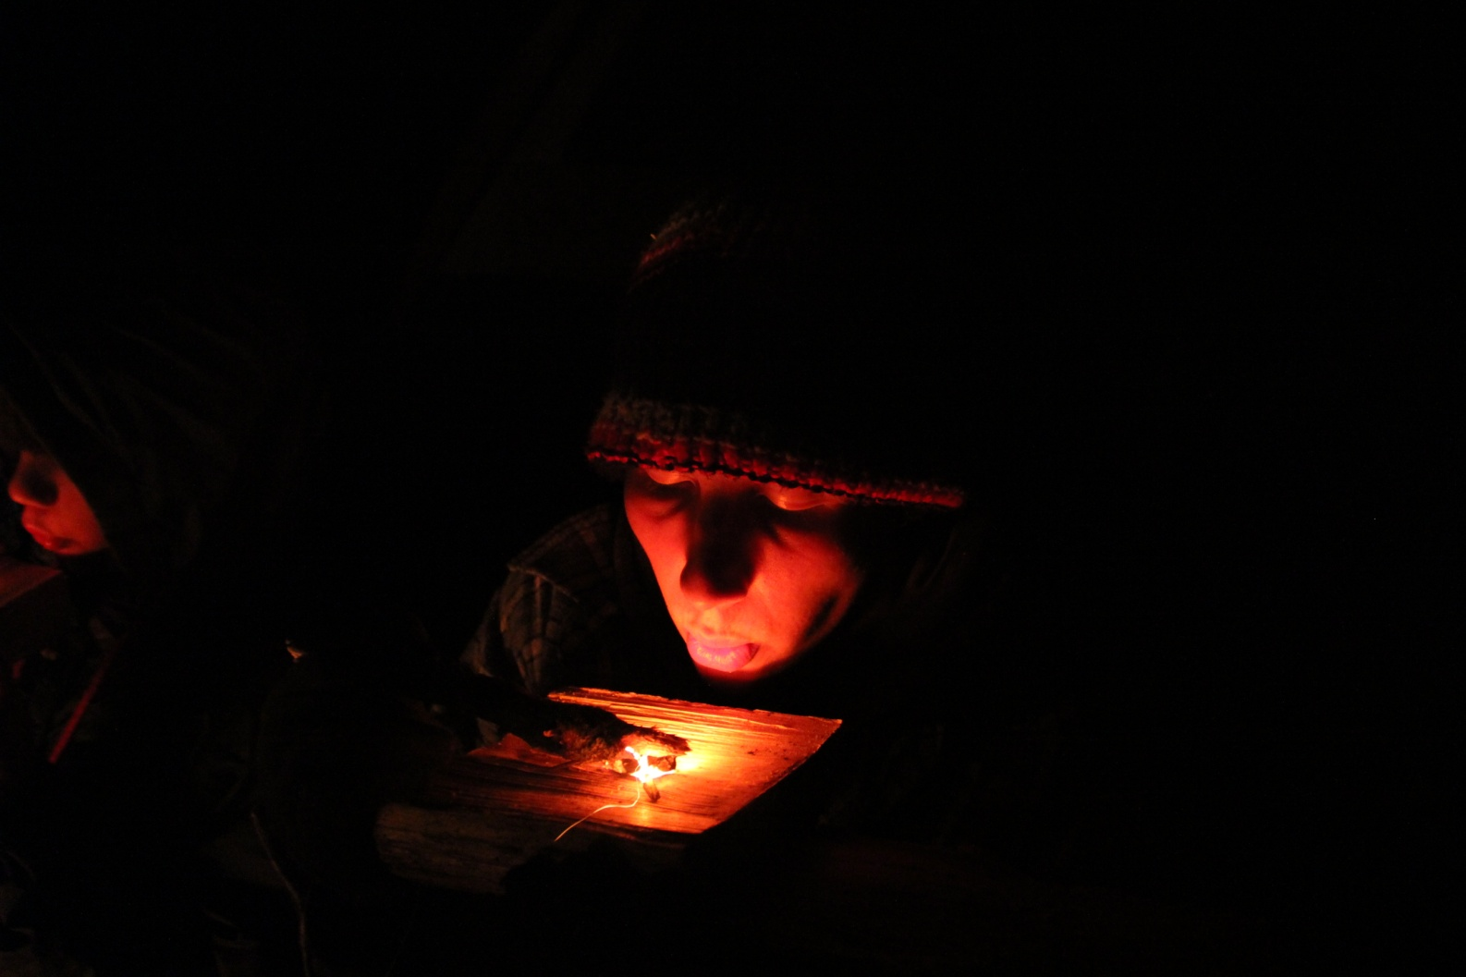
Bowl Burning
NOVEMBER | S | M | T | W | T | F | S
NOVEMBER |  |  |  |  |  | 1 | 2
NOVEMBER | 3 | 4 | 5 | 6 | 7 | 8 | 9
2013 | 10 | 11 | 12 | 13 | 14 | 15 | 16
2013 | 17 | 18 | 19 | 20 | 21 | 22 | 23
2013 | 24 | 25 | 26 | 27 | 28 | 29 | 30

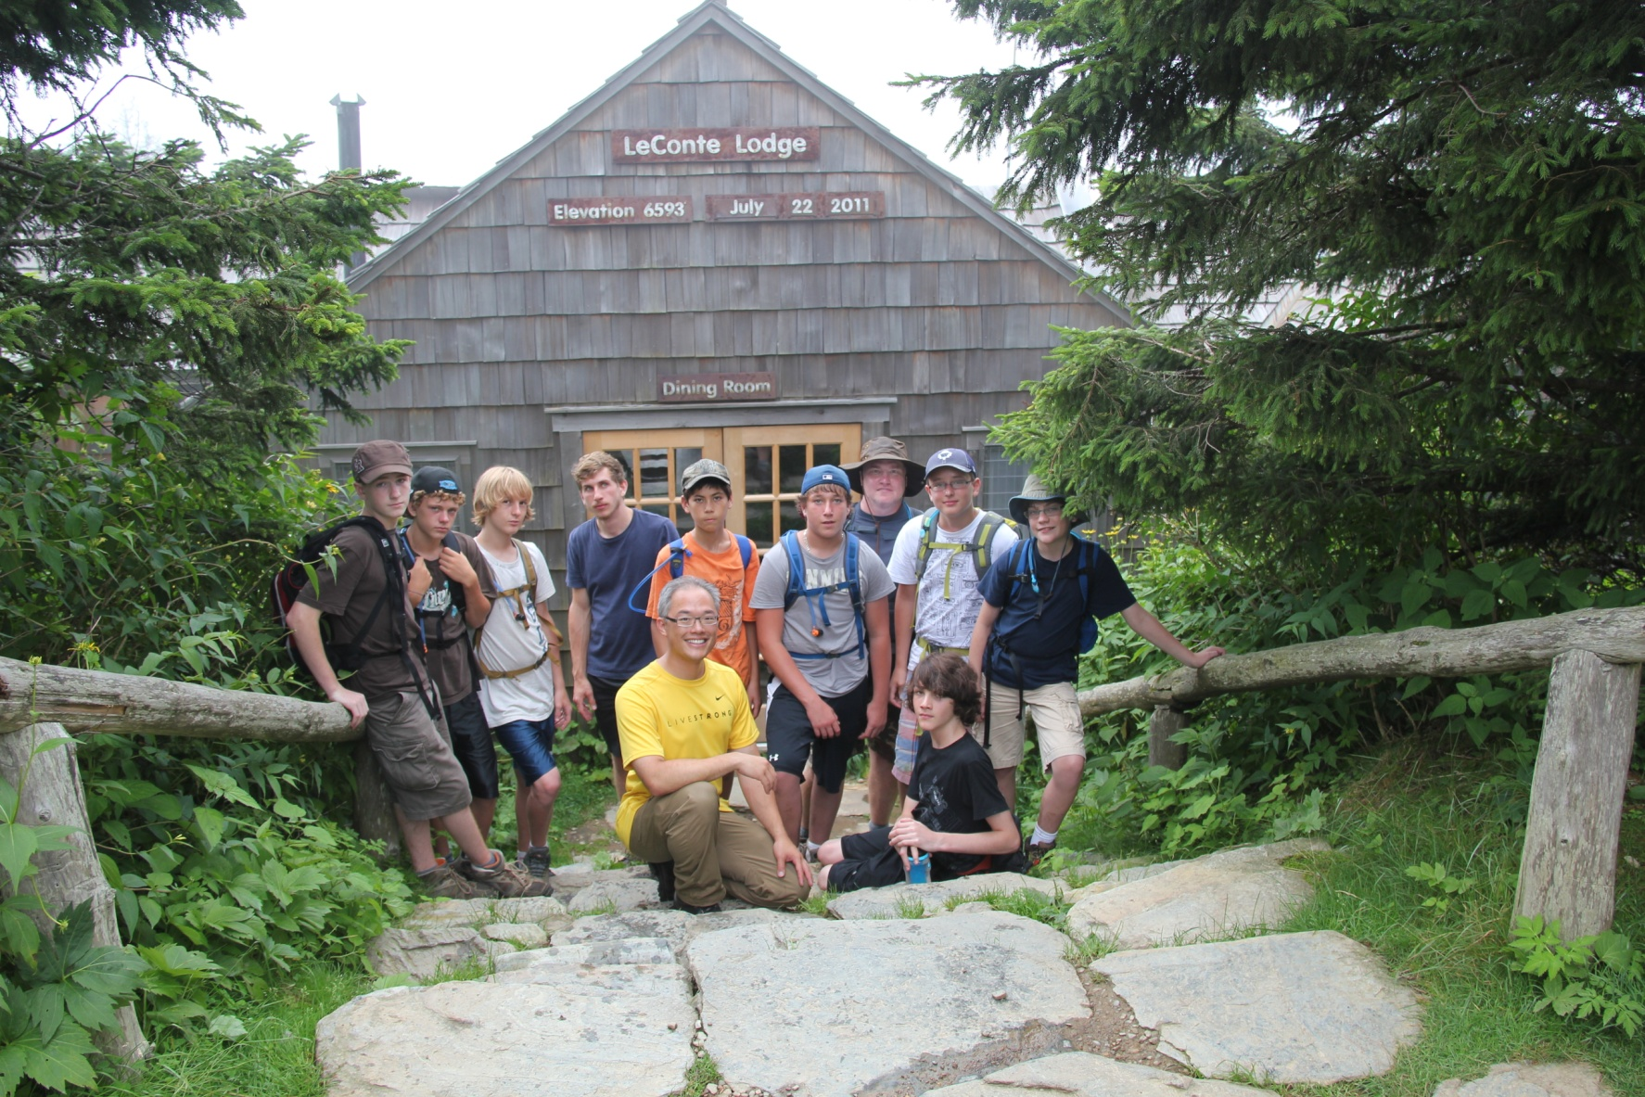
Mt. LaComte Hike
DECEMBER | S | M | T | W | T | F | S
DECEMBER | 1 | 2 | 3 | 4 | 5 | 6 | 7
DECEMBER | 8 | 9 | 10 | 11 | 12 | 13 | 14
2013 | 15 | 16 | 17 | 18 | 19 | 20 | 21
2013 | 22 | 23 | 24 | 25 | 26 | 27 | 28
2013 | 29 | 30 | 31

